7D FROM HEXADECIMAL TO DECIMAL

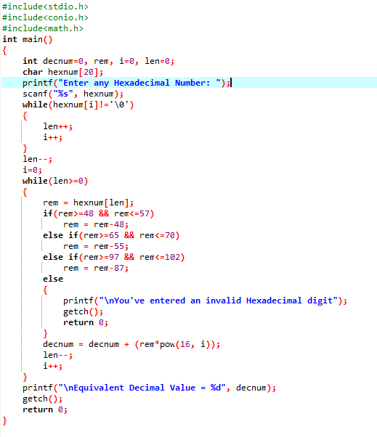

OUTPUT

